**Ayesha Zubair**

**52916**

**Lab 8**

**Task 1: Write a C++ program that uses two fork() calls . Each process should:**

1. Print its process ID (PID) and a loop value from 1 to 20.

**Code:**

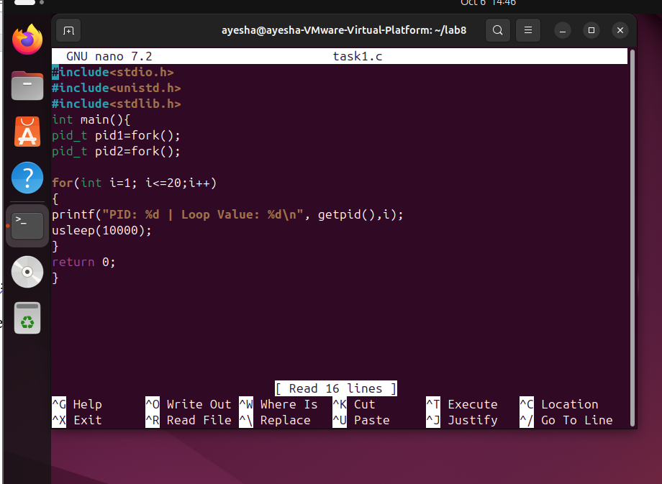

**Output:**

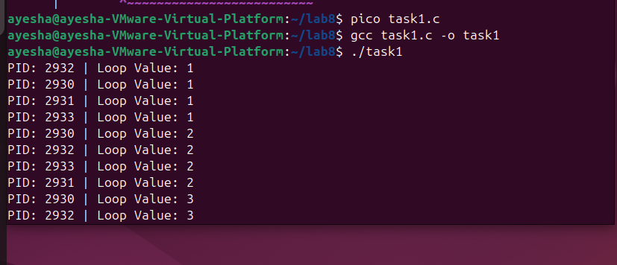

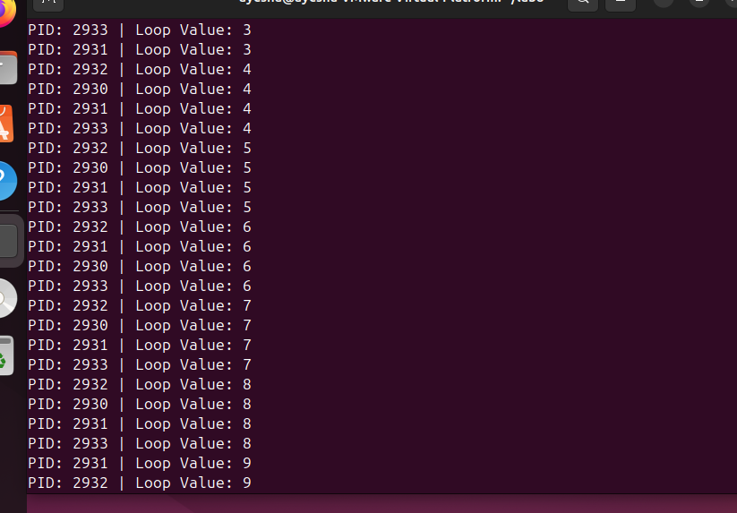

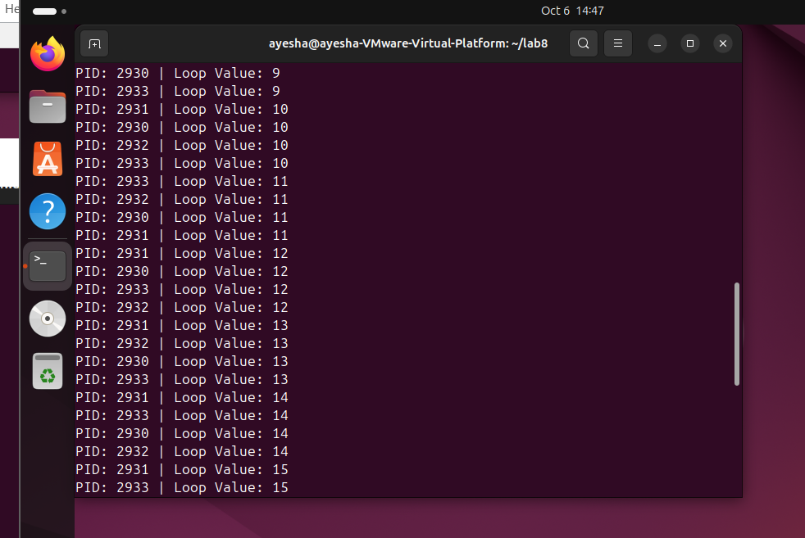

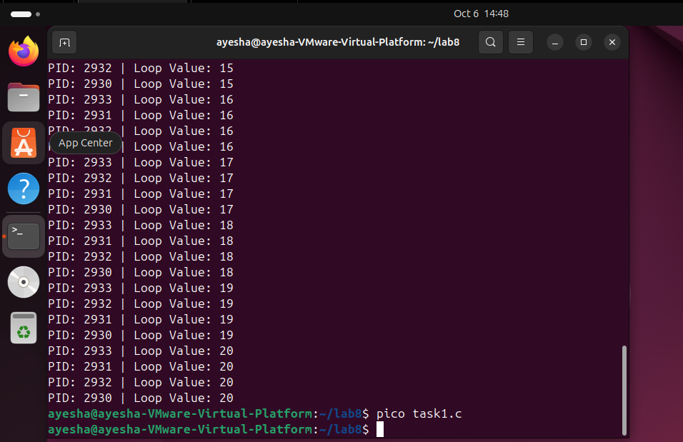

**Task 2: Write a C++ program that creates three child processes using the fork() system call. Each child process should:**

1. Print its own process ID (PID) and its parent process ID (PPID).
2. Terminate using exit().
3. After creating the child processes, the parent process should print its own PID.

**Code:**

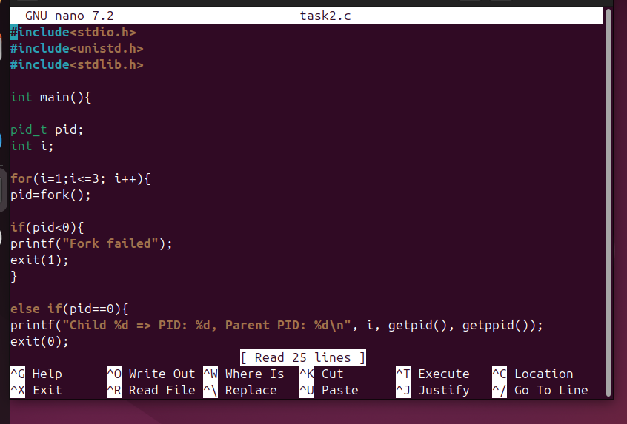

**Output:**

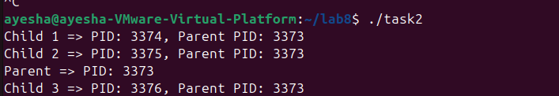

**Task3: Explain the working of system calls with its types and examples according to your understanding.**

**System Calls:** These are the methods by which users request services from the kernel.

**Fork():** This creates a copy of the current process with different process ids.

**exec():** Replaces the current process with a new program but the id remains the same.

**Wait():** The parent process waits for the child process execution to finish and then continues its own execution.

**Exit():** Exit system calls ends a process.

**Getpid():** Returns the process id of the current process.

**Getppid():** Returns process id of the parent process.